Comparing Similar Suburbs in the Vacinity of Philadelphia, PA
Marylin Huff
July 26, 2020

- Introduction
When I moved to the town I now live in, our selection criterion was good schools. Over time, I have grown to love the quaint shops and independent restaurants. Now that the kids are grown and we are downsizing, I'd like to find a similar neighborhood with these amenities and low property taxes since I no longer care about the quality of the schools.
- Data Acquisition and Cleaning
To accomplish this, I will need to gather data on neighborhoods around Philadelphia, property tax data, and venue information. The data will need to be joined by zipcode and/or municipality.
2.1 Neighborhood and Zipcode Information
The Neighborhood and zipcode data for the Philadelphia metro area can be found on this website: https://namecensus.com/igapo/zip_codes/metropolitan-areas/metro-alpha/Philadelphia%20(PA-NJ)1.html. This data includes the zipcode and municipality, telephone area code, county, state, and some extraneous information that I will not need.

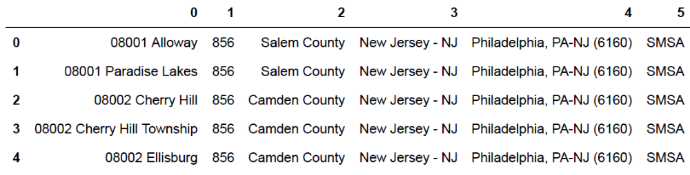
This data has to be cleaned to separate the zip codes and municipalities into separate columns, correct data types, and eliminate extraneous information. I am also limiting the exploration to only Delaware and Montgomery counties in PA.
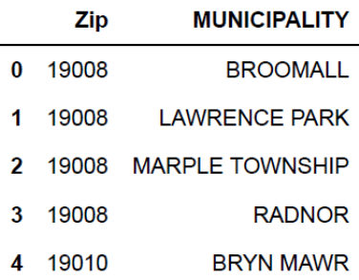

  - Property Tax Information

The property tax information for Delaware County can be found on this website: https://www.delcopa.gov/treasurer/propertytaxes.html as a PDF. I exported the PDF to Excel, trimmed out extraneous information, and renamed the columns. The property tax information for Montgomery County, PA can be found on this website: https://www.montcopa.org/622/County-Municipality-Millage-Rates. I trimmed out extraneous information. I then combined the information in a single dataframe and linked it with the zip codes found previously:
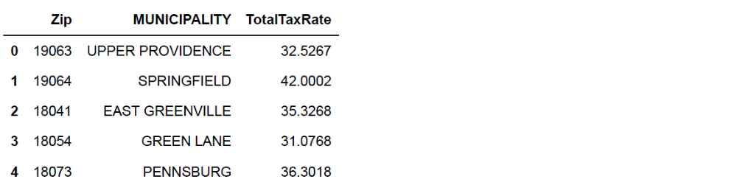
  - Associate Coordinates with each municipality based on zipcode
Coordinates as a function of zip code can be found at this website:
https://public.opendatasoft.com/explore/dataset/us-zip-code-latitude-and-longitude/table/?refine.state=PA
I downloaded the data as a excel file and trimmed out the extraneous information. I then merged the data.
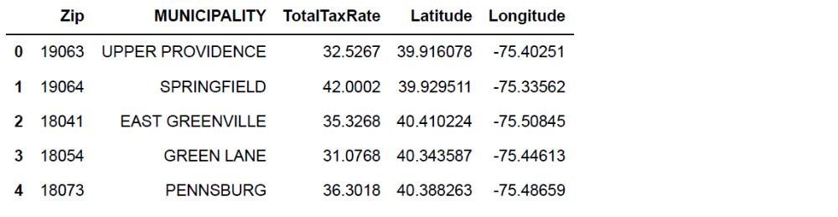
Here are the municipalities being explored:
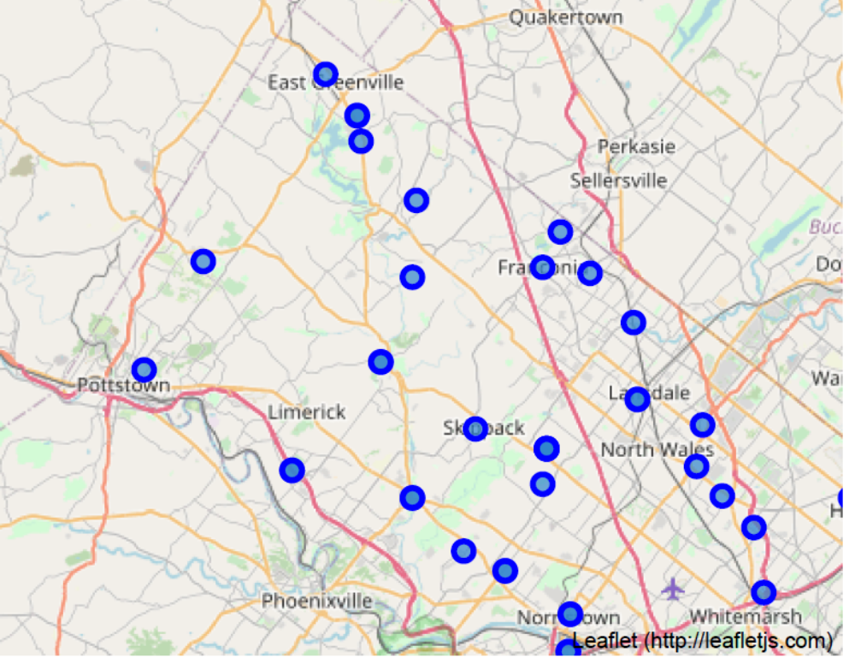
- Methodology
I then used Foursquare to find venues within 200m of each municipality. I clustered the municipalities based on similarities of the 10 most common nearby venues. I chose 8 clusters and the municipality I currently live in is in the 2nd cluster.

- Results
The tax data was combined with the similar venue data for the second cluster:
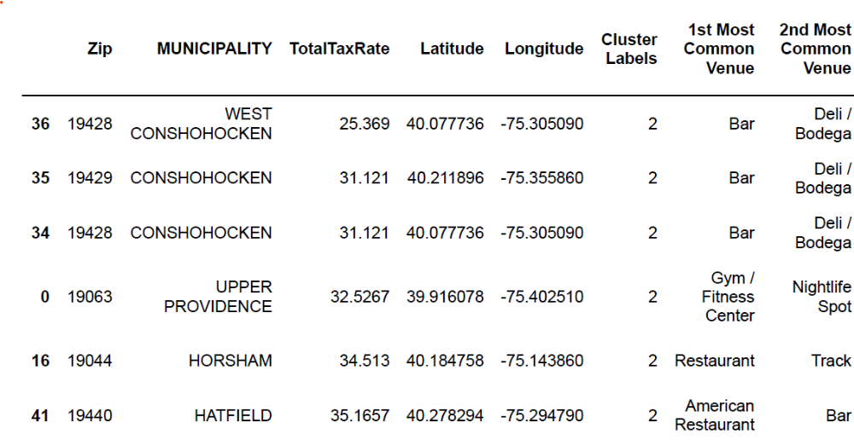
This shows that municipalities with the lowest total tax rate that are otherwise similar to my current municipality are West Conshohocken, Conshohocken, Upper Providence, Horsham, and Hatfield.
- Conclusions
It would be prudent to look for homes in West Conshohocken, Conshohocken, Upper Providence, Horsham, and Hatfield.

